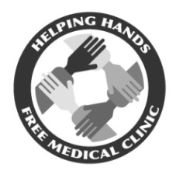
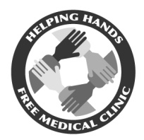
Helping Hands Free Medical Clinic
230 South Main Street 1328 North Main Street
Mullins, South Carolina 29574 Marion, South Carolina 29571
Phone (843) 464 – 8750 Phone (843) 423 – 5212
Fax (843) 464 – 0938 Fax (843) 423 – 5593
Hours: Mon – Thurs, 9am – 4pm Hours: Thurs & Fri, 9am – 12pm
Lunch: 12pm – 1pm

# of Persons in Household | Total Household Income  (200% Annual)
1 | $23,340
2 | $31,460
3 | $39,580
4 | $47,700
5 | $55,820
QUALIFICATIONS TO BE A PATIENT
- Resident of Marion County or surrounding communities
- No health insurance (Medicare, Medicaid, private insurance, etc.)
- Between the ages of 18 – 64
- Household income must not be above Federal Poverty Guidelines

ELIGIBILITY FORM
(FOR NEW PATIENTS AND PATIENTS WHO HAVE NOT BEEN SCREENED FOR ELIGIBILITY IN ONE YEAR)

(OFFICE PERSONNEL ONLY) EXPIRES ON
Full Name Date
Current Address Primary Phone
Secondary Phone
ITEMS TO BRING CHECK LIST

- Current South Carolina picture ID

- Social Security card

- Current Medicaid denial letter or 3300 form (dated within one year)
Medicaid Office located at: 137 Airport Court, Suite J, Mullins, SC (Mon – Fri, 8:30am – 5:00pm)

- Any household bills in your name
(ie. light, water, phone, cable, mortgage, medical bills, etc.)
If no bills: provide a monthly sample of mail with name and current address

- Proof of household income
(ie. W2, 1040 tax form, or most recent check stubs)
If no income: signed statement from person providing room and board, food, etc.

€ Food stamp print-out € N/A

€ Social Security or Disability Award Letter (with current year) € N/A

€ Child support or alimony (received or provided) € N/A

€ Worker’s compensation print-out € N/A

€ Unemployment payment history print-out € N/A

